**Create the above tables by properly specifying the primary keys and the foreign**

**keys.**

**Enter at least five tuples for each relation.**

create database bank;

use bank;

CREATE TABLE branch(

branch_name VARCHAR(30) PRIMARY KEY,

branch_city VARCHAR(30),

assets INT

);

CREATE TABLE bankaccount(

accno INT PRIMARY KEY,

branch_name VARCHAR(30),

balance INT,

FOREIGN KEY (branch_name) REFERENCES branch(branch_name)

);

CREATE TABLE bankcustomer(

customer_name VARCHAR(30) PRIMARY KEY,

customer_street VARCHAR(30),

customer_city VARCHAR(30)

);

CREATE TABLE depositor(

customer_name VARCHAR(30),

accno INT,

PRIMARY KEY (customer_name, accno),

FOREIGN KEY (customer_name) REFERENCES bankcustomer(customer_name),

FOREIGN KEY (accno) REFERENCES bankaccount(accno)

);

CREATE TABLE loan(

loan_number INT PRIMARY KEY,

branch_name VARCHAR(30),

amount INT,

FOREIGN KEY (branch_name) REFERENCES branch(branch_name)

);

INSERT INTO branch VALUES

('SBI_Chamrajpet','Bangalore',50000),

('SBI_ResidencyRoad','Bangalore',10000),

('SBI_ShivajiRoad','Bombay',20000),

('SBI_ParliamentRoad','Delhi',10000),

('SBI_Jantarmantar','Delhi',20000);

INSERT INTO bankaccount VALUES

(1,'SBI_Chamrajpet',2000),

(2,'SBI_ResidencyRoad',5000),

(3,'SBI_ShivajiRoad',6000),

(4,'SBI_ParliamentRoad',9000),

(5,'SBI_Jantarmantar',8000),

(6,'SBI_ShivajiRoad',4000),

(8,'SBI_ResidencyRoad',4000),

(9,'SBI_ParliamentRoad',3000),

(10,'SBI_ResidencyRoad',5000),

(11,'SBI_Jantarmantar',2000);

INSERT INTO bankcustomer VALUES

('Avinash','Bull_Temple_Road','Bangalore'),

('Dinesh','Bannergatta_Road','Bangalore'),

('Mohan','NationalCollege_Road','Bangalore'),

('Nikil','Akbar_Road','Delhi'),

('Ravi','Prithviraj_Road','Delhi');

INSERT INTO depositor VALUES

('Avinash',1),

('Dinesh',2),

('Nikil',4),

('Ravi',5),

('Avinash',8),

('Nikil',9),

('Dinesh',10),

('Nikil',11);

INSERT INTO loan VALUES

(1,'SBI_Chamrajpet',1000),

(2,'SBI_ResidencyRoad',2000),

(3,'SBI_ShivajiRoad',3000),

(4,'SBI_ParliamentRoad',4000),

(5,'SBI_Jantarmantar',5000);

select * from loan;

select * from depositor;

select * from branch;

select * from bankaccount;

select * from bankcustomer;

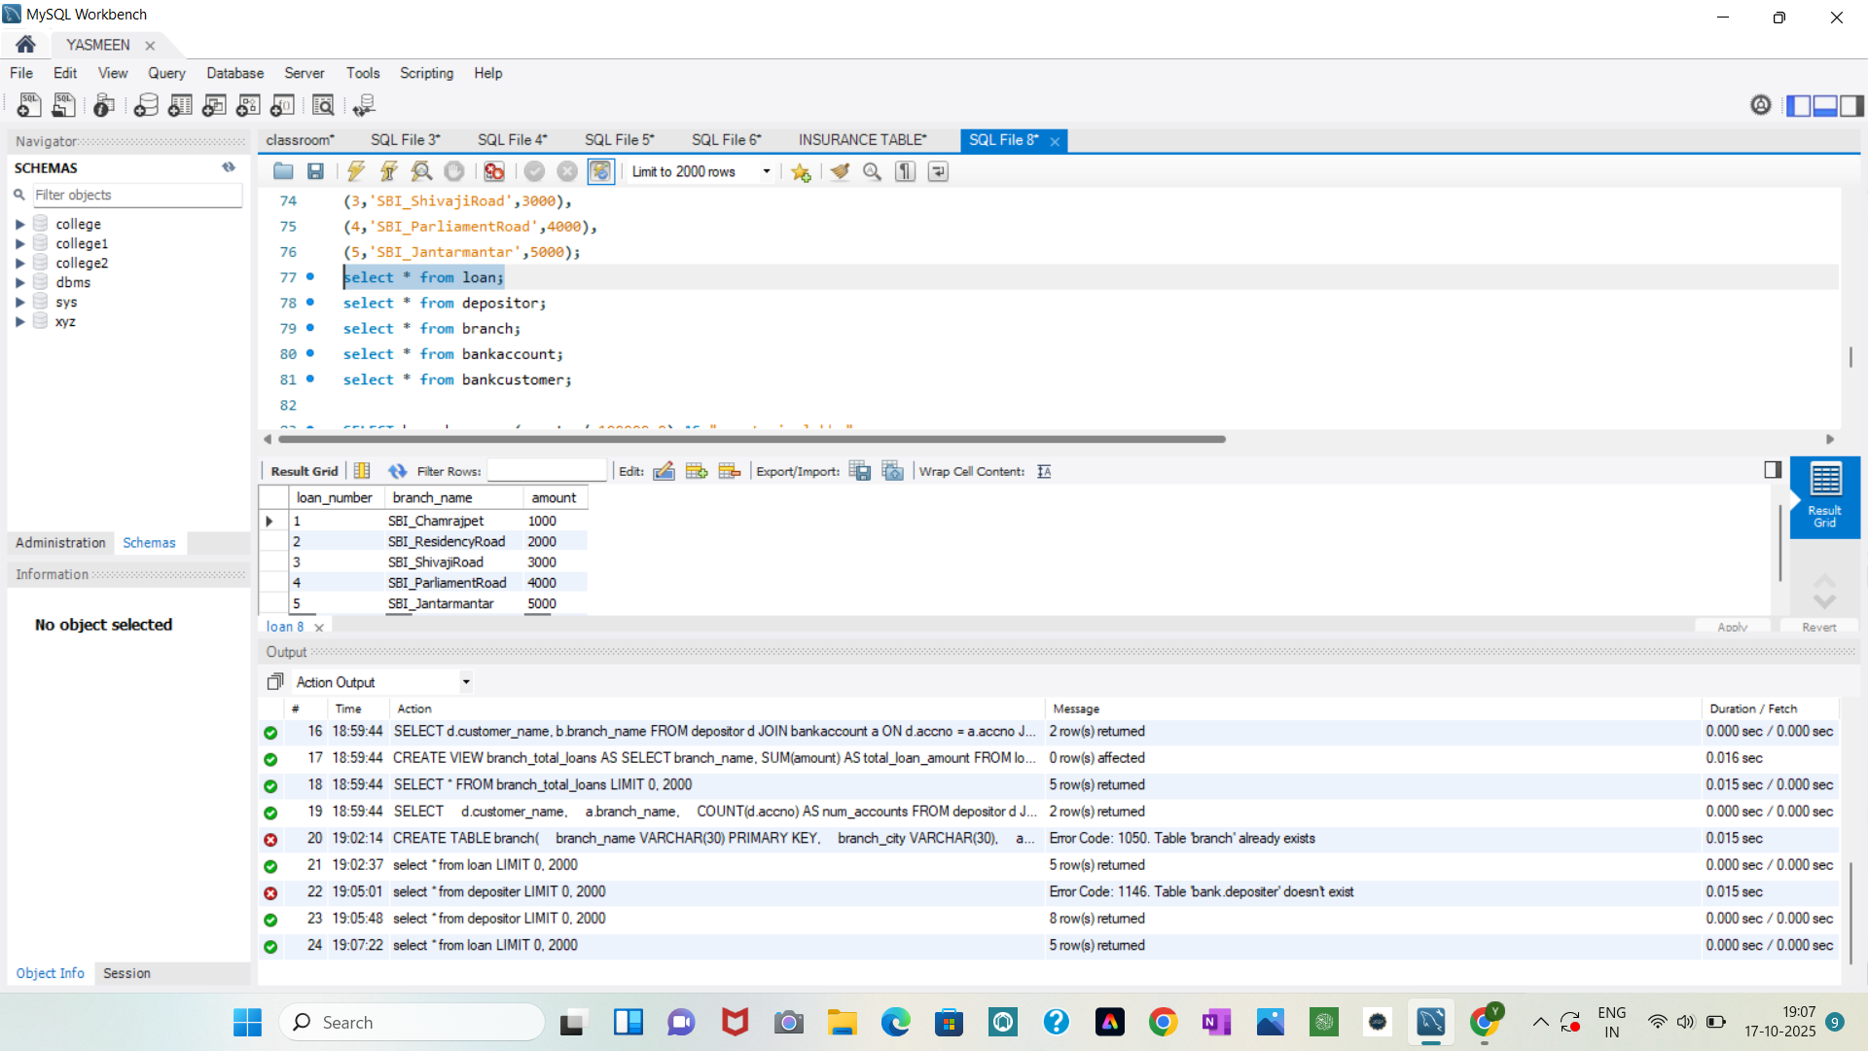

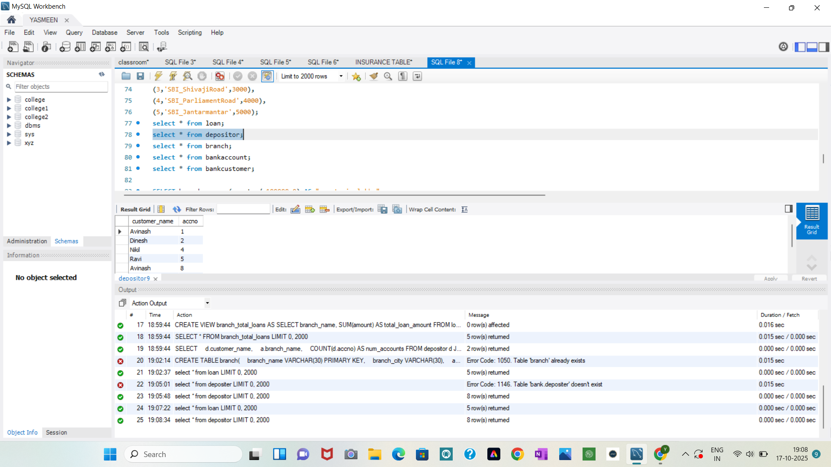

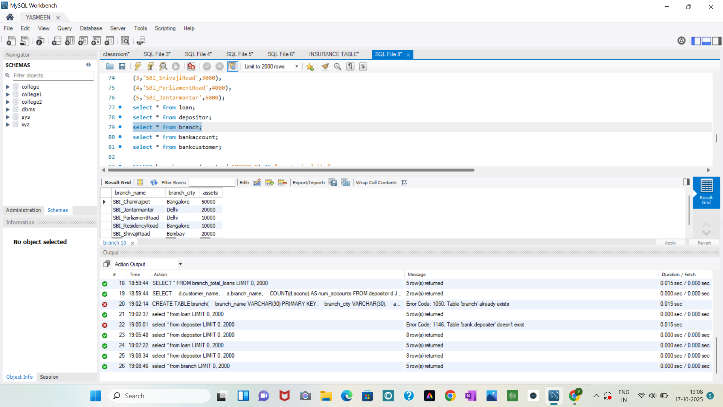

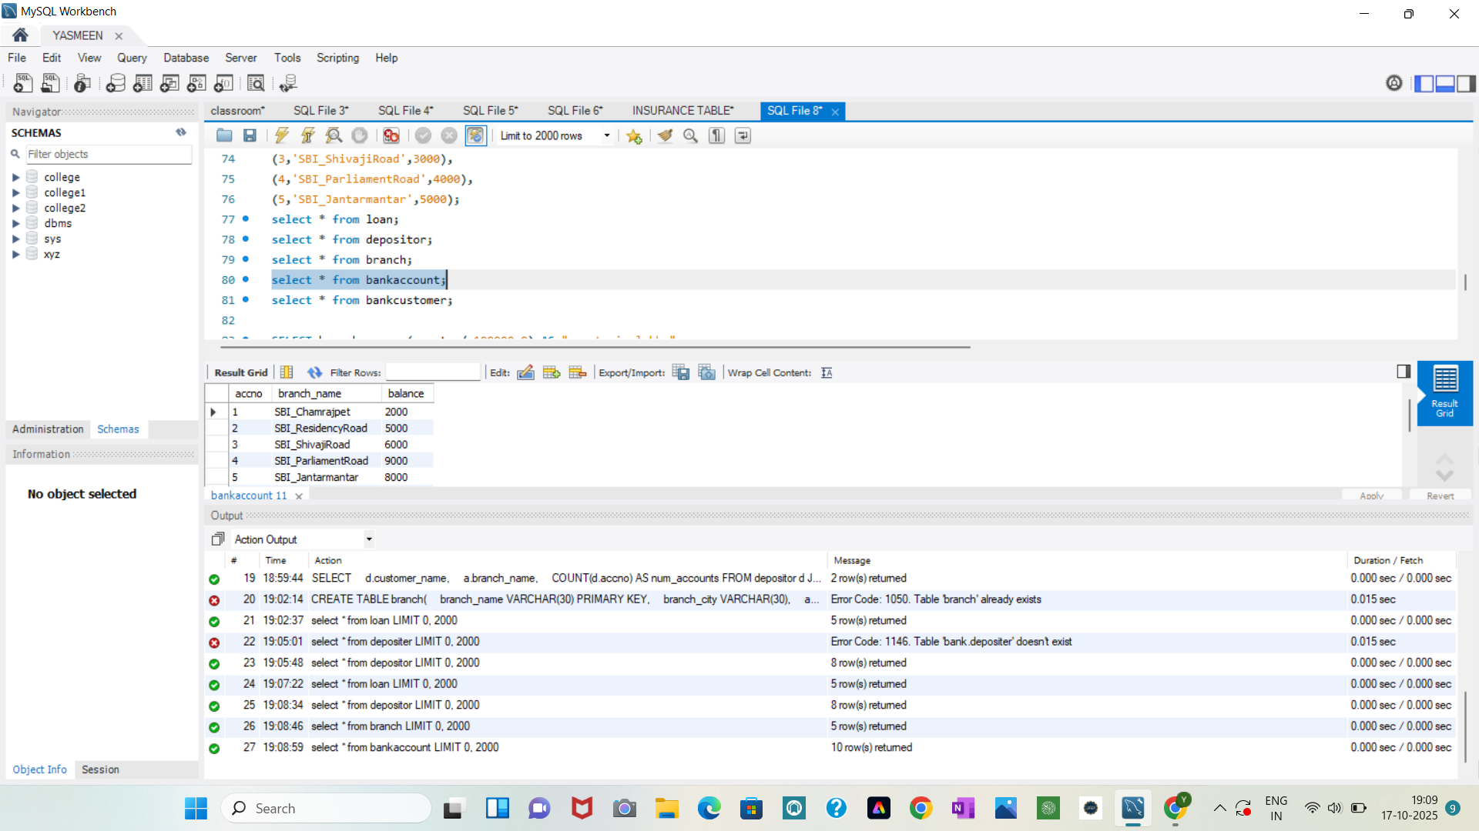

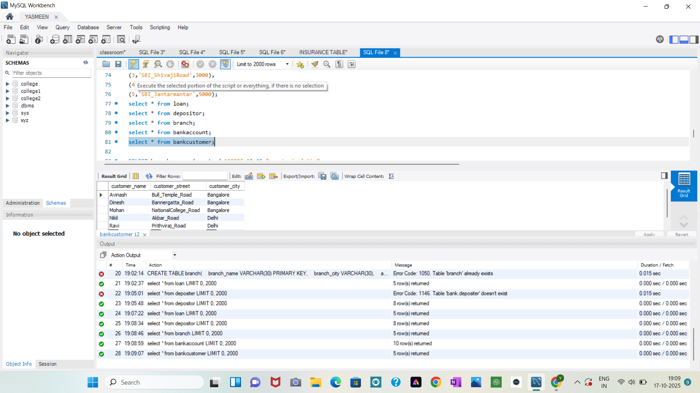

**Display the branch name and assets from all branches in lakhs of rupees and rename**

**the assets column to 'assets in lakhs'.**

SELECT branch_name, (assets / 100000.0) AS "assets in lakhs"

FROM branch;

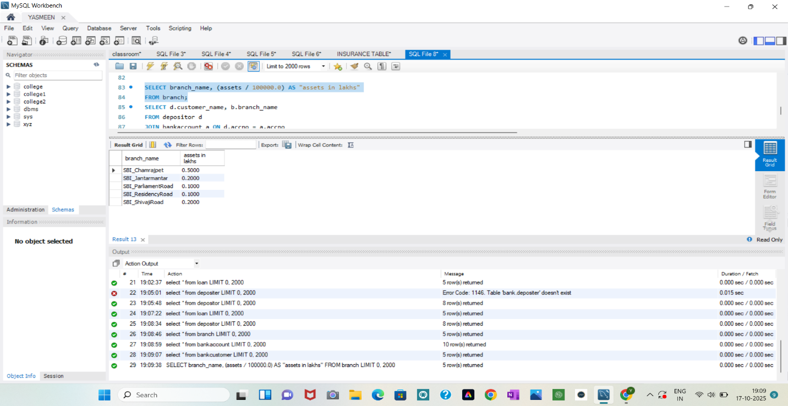

**Find all the customers who have at least two accounts at the same branch (ex.**

**SBI_ResidencyRoad).**

SELECT d.customer_name, b.branch_name

FROM depositor d

JOIN bankaccount a ON d.accno = a.accno

JOIN branch b ON a.branch_name = b.branch_name

GROUP BY d.customer_name, b.branch_name

HAVING COUNT(d.accno) >= 2;

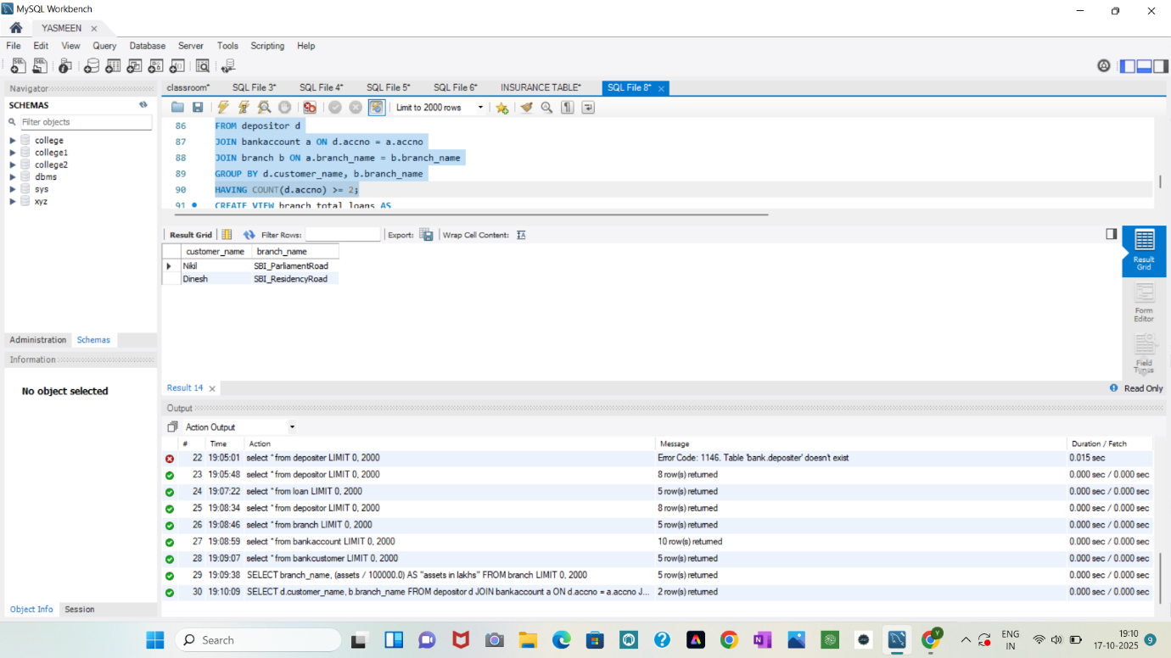

**CREATE A VIEW WHICH GIVES EACH BRANCH THE SUM OF THE**

**AMOUNT OF ALL THE LOANS AT THE BRANCH.**

CREATE VIEW branch_total_loans AS

SELECT branch_name, SUM(amount) AS total_loan_amount

FROM loan

GROUP BY branch_name;

SELECT * FROM branch_total_loans;

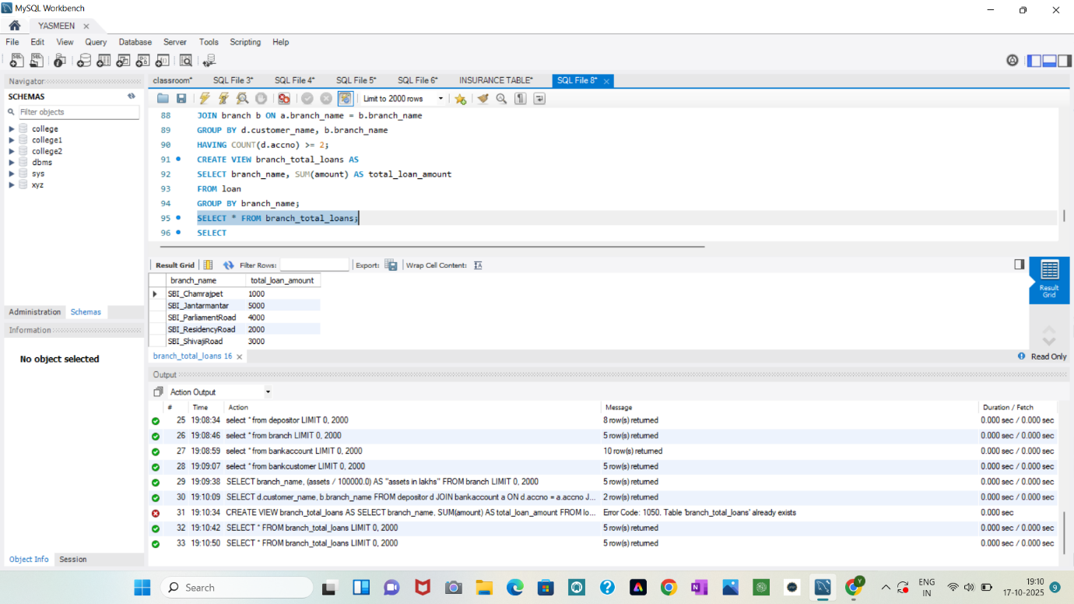

**CREATE A VIEW WHICH GIVES EACH BRANCH THE SUM OF THE**

**AMOUNT OF ALL THE LOANS AT THE BRANCH.**

SELECT

d.customer_name,

a.branch_name,

COUNT(d.accno) AS num_accounts

FROM depositor d

JOIN bankaccount a ON d.accno = a.accno

GROUP BY d.customer_name, a.branch_name

HAVING COUNT(d.accno) >= 2;

